**ASSESMENT 2 JARKOM**

**ANGGOTA KELOMPOK :**

**DHAFIN KHAIRAN**

**DHIMAS ABIYYAN PUTRA**

**MUHAMAD ANGGA YUDHA**

**MUHAMMAD ZAKHWAN A**

**AFIF NURDWI WIJAKSONO**

**ARIEL KRISTIAN GULTOM**

1. Ping PC Net A ke PC Net B

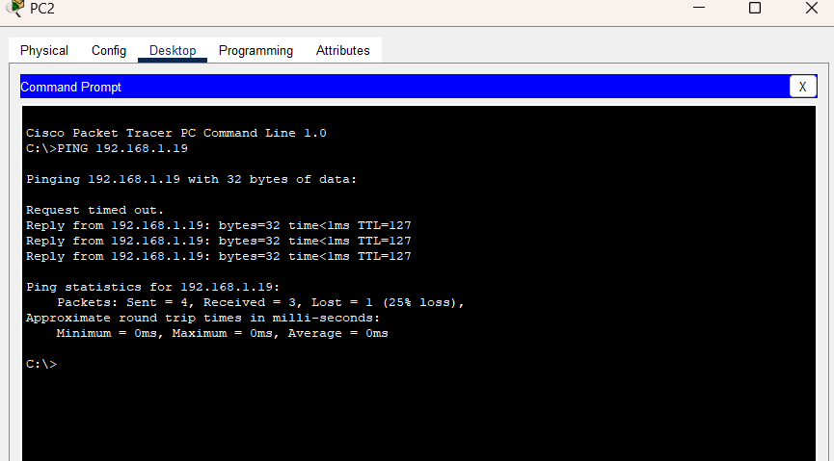

1. Ping PC Net A ke PC Net D

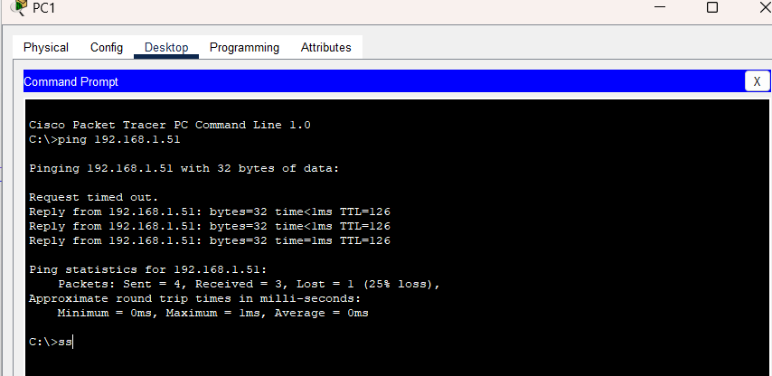

3)Ping PC Net D ke Net E

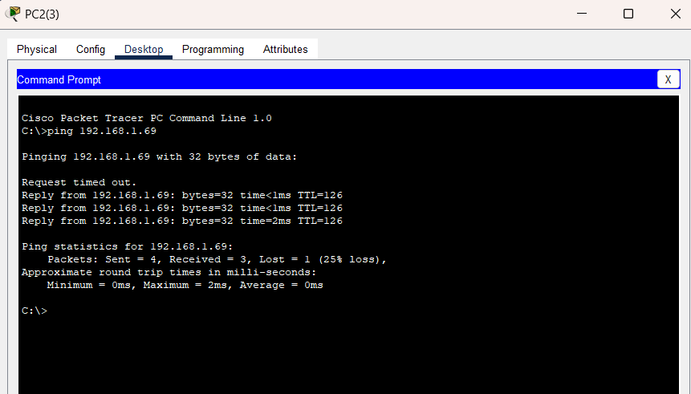

4)Ping PC Net C ke Net F

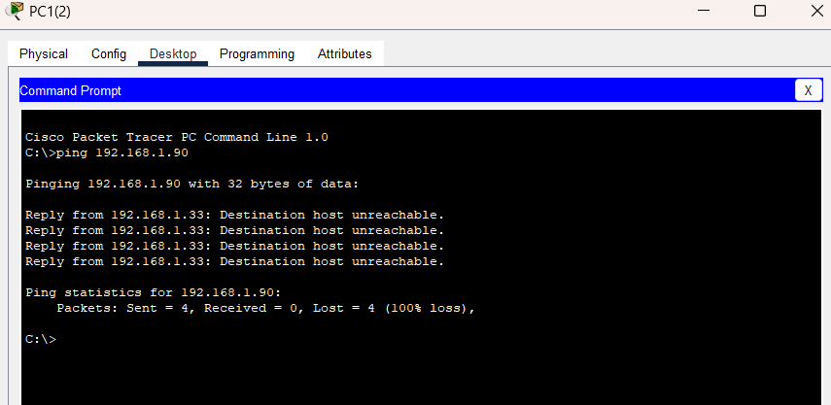

5) Ping PC Net J ke PC Net L

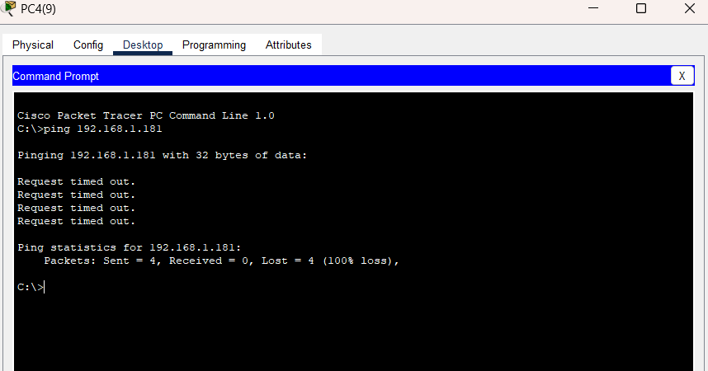

6) Ping PC Net J ke PC Net A

